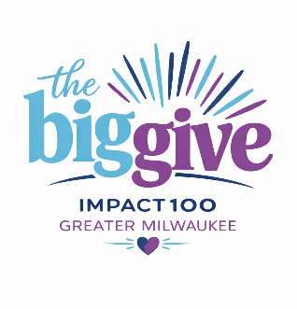

How to Vote at the Annual Awards Celebration

Impact100 Greater Milwaukee hosts its Annual Awards Celebration #TheBigGive each June. Following a rigorous evaluation process by our members, the finalists present their projects to the full membership at this event. Immediately following, our members vote and the grant recipients are announced. Votes will be cast using a link to OPAVOTE on their phones. For every 100 members, we award one $100,000 grant and divide the balance of funds among the remaining finalists. The more members we have, the more we can award!

ACTION REQUIRED! UPDATE YOUR EMAIL ADDRESS ASAP! Each 2025-2026 member will receive her customized voting link via email. The email will come directly from OPAVOTE, our online voting platform. This email will go directly to the email address associated with you in the Impact100 Member Profile.

Take these two steps to be ready to cast your vote!
- Go now to the member portal at www.Impact100mke.org to make sure your desired email address is in your profile. It’s easy to change but please do so promptly to ensure we capture it for the voting email. Using a business email address? In recent years, we’ve experienced some businesses employing firewalls that may block certain external emails. If you think that’s possible, you could use an alternative email or simply make sure to follow step 2 below.

- On Tuesday, May 26, check that you received the email from OpaVote containing your customized voting link. Don’t see it? Check your spam or trying to search your email box for “OpaVote”. Still can’t find it? Email grants@impact100mke.org. We can help!

Please seek early assistance at the event’s Information Table if you cannot find the OpaVote email. We will be happy to assist you.

LEARN ABOUT OUR FINALISTS We fund capital projects, new programs, expansions of existing programs, or new/expanded collaborative effort between several nonprofit organizations. All grants target a specific population for a specific duration with specific measurable goals in one of these areas of focus:

The Grant Committees are made up of all volunteer members of Impact100 who conduct a rigorous review process of numerous grant applications and ultimately recommend five finalists. We will announce these finalists on May 7, 2026, and then provide project summaries to our membership on May 15, 2026. These finalists will present their projects at #TheBigGive.

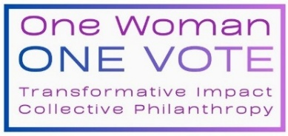
HOW TO VOTE? You MUST be a 2025-2026 Impact100 Member in order to Vote! Please check your Member Portal to confirm your status. All members will receive a reminder email from OpaVote on June 2 to ensure the voting link is at the top of your inbox! (If you don’t see the OpaVote email that afternoon, check your spam folder!) Bring your phone and have the voting link handy.

UNABLE TO ATTEND THE BIG GIVE? If you’re voting absentee, you may use the voting link any time before June 2 at 4pm. If you’re attending the Annual Awards Ceremony in person, wait to vote until you hear the presentations!

Voting questions? Email us at grants@impact100mke.org.

